Machacon, Zach Riane BS Computer Engineering 3

Cena, Adrian Miguel September 8, 2023

**Exercise 1**

**1.a**

1.b

1.c

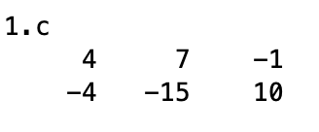

2.

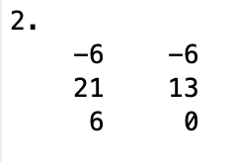

3.

4.

5.

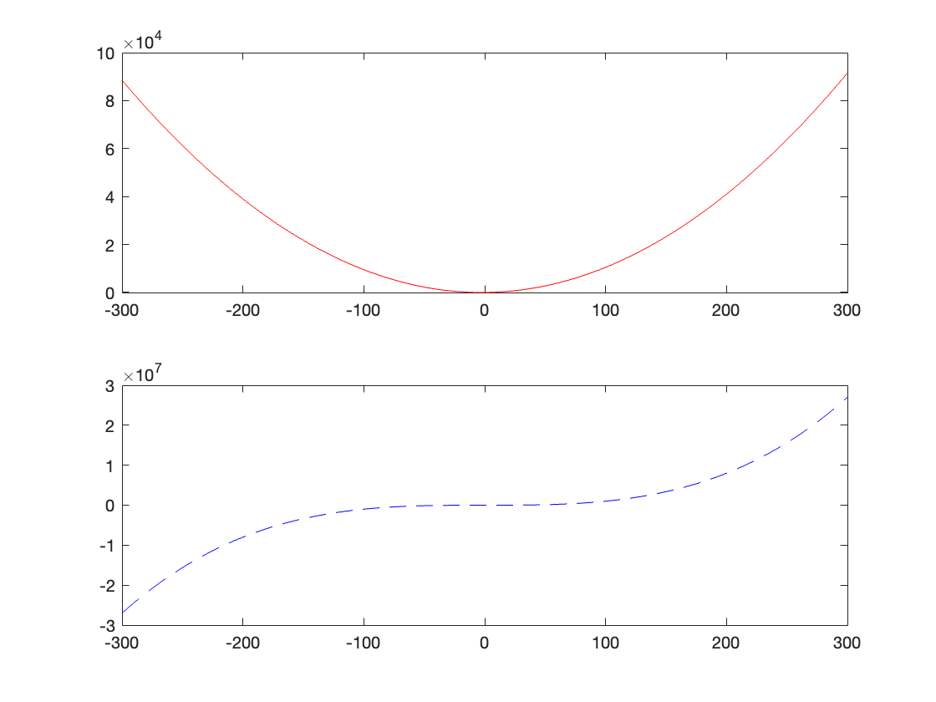

6.

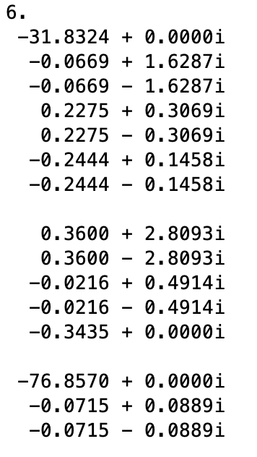

7.

